Product Discontinuance Bulletin
Issue Date: October 2015

Product

Masterclock’s MCR1000 Time Sever, also known as the MCR1000
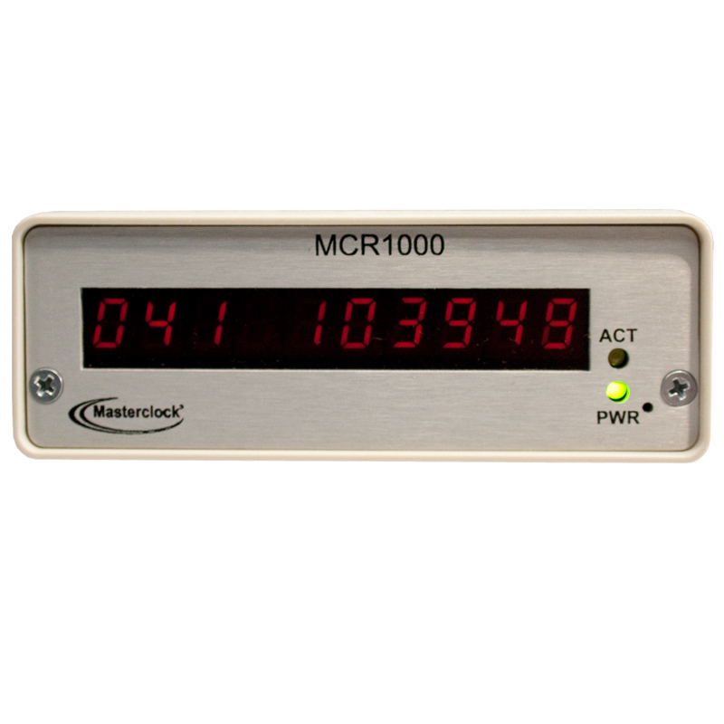

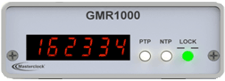

Discontinued MCR1000 Replacement GMR1000

Overview

Masterclock is announcing the discontinuance of the MCR1000 Time Server. The MCR1000 has reached the end of its technology product lifecycle and the manufacturing of the product is being discontinued.

Product Obsolescence Timeline
We have verified replacement functionality and we are currently fulfilling outstanding quotations for the MCR1000. All future quotations will be replaced with the GMR1000.

Contact Information
Masterclock Inc. +1-636-724-3666
1-800-940-2248 (toll free)

Masterclock Customer Service +1-636-724-3666
1-800-940-2248 (toll free)
support@masterclock.com
www.masterclock.com

Masterclock Inc. 2484 West Clay Street
Saint Charles, MO 63301
Telephone: +1-636-724-3666
Facsimile: +1-636-724-3776

