Product Discontinuance Bulletin
Issue Date: October 2015

Product

Masterclock’s MCR5000 Time Sever, also known as the MCR5000
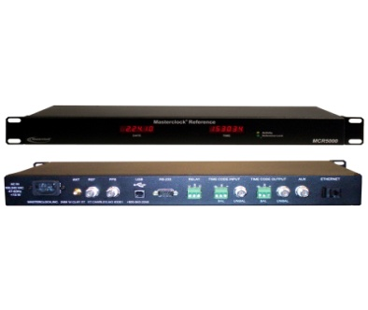

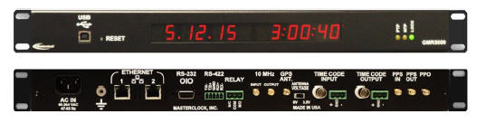

Discontinued MCR5000 Replacement GMR5000

Overview

Masterclock is announcing the discontinuance of the MCR5000 Time Server. The MCR5000 has reached the end of its technology product lifecycle and the manufacturing of the product is being discontinued.

Product Obsolescence Timeline
We have verified replacement functionality and we are currently fulfilling outstanding quotations for the MCR5000. All future quotations will be replaced with the GMR5000.

Contact Information
Masterclock Inc. +1-636-724-3666
1-800-940-2248 (toll free)

Masterclock Customer Service +1-636-724-3666
1-800-940-2248 (toll free)
support@masterclock.com
www.masterclock.com

Masterclock Inc. 2484 West Clay Street
Saint Charles, MO 63301
Telephone: +1-636-724-3666
Facsimile: +1-636-724-3776

